Introduction to the Bistable multivibrator

Objective: | To familiarize with the characteristics and application of: Gated S-C Latch, D-Latch and JK-flip-flop.
Equipment  required: | Logic probe  Digital trainer  Notebook installed with NI Multisim
ICs required: | 74LS00 - NAND gate  74LS04 - NOT gate  74LS112 - JK edge-triggered flip-flop

Experiment A Gated S-C Latch circuit

Objective : | To investigate the operation of a gated S-C Latch circuit

 | Start NI Multisim from your Notebook and then capture the circuit as shown in figure 5.1. In addition to the four 2-input NAND gates, three DPST switches, Vcc and DGnd, two probes will be required for the outputs. Name all your input and output signals according to figure 5.1. Simulate the circuit using the input combinations as specified in truth table 5.1.

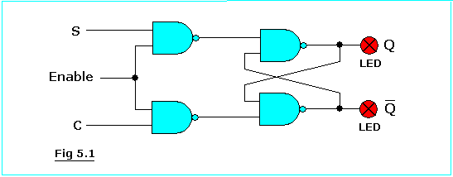

1. To start a new circuit, launch the NI Multisim Simulation software from Start » Programs » National Instruments » Circuit Design Suite 10.0 » and then select Multisim.

Proceed to capture the circuit shown in figure 5.1. Place the required components in the drawing page as shown in figure 5.1a. For the required NAND gates, you may use actual IC devices instead of generic gates by accessing the TTL/74LS library. Select 74LS00N for the NAND gates and one IC would suffice. Complete the schematic capture according to figure 5.1 and simulate your circuit by toggling the switches in accordance with the combinational sequence shown in the truth table of Table 5.1. Record the status of the probes in the output columns of the table.

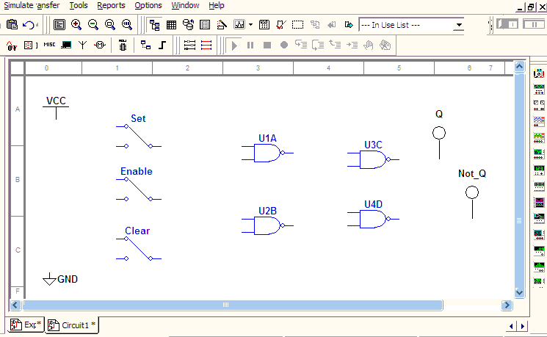
Figure 5.1a

2. Using the digital trainer, connect up your circuit as shown in figure 5.1 with the S, C and Clock inputs going to the toggle switches on your trainer. Verify that the results are similar to what you obtained through simulation by varying the inputs C, S and Enable in the same sequence shown.

 | Enable | S | C | Q | NOT Q | Remarks
1 | 1 | 0 | 1
2 | 1 | 1 | 0
3 | 1 | 0 | 0
4 | 1 | 1 | 1
5 | 1 | 0 | 1
6 | 0 | 0 | 1
7 | 0 | 0 | 0
8 | 0 | 1 | 1
9 | 0 | 1 | 0
10 | 1 | 1 | 0
11 | 0 | 1 | 0
12 | 0 | 0 | 1

Table5.1 Gated S-C Latch using NAND gates

3. Interpret your results recorded in table 5.1 and hence, complete the table 5.1.2.

Enable | S | C | Q | Not Q
1 | 0 | 0
1 | 0 | 1
1 | 1 | 0
1 | 1 | 1
1 | 0 | 1
0 | 1 | 0
0 | 1 | 1
Table 5.1.2

 | If S = 1 and C = 0 and the enable is 0 or low - Q = ___
 | If S = 0 and C = 1 and the enable is 1 or high - Q = ___
 | If S = 1 and C = 0 and the enable is 1 or high - Q = ___
 | If S = 1 and C = 1 and the enable is 1 or high - Q = ___

Write in your own words the conclusions you can draw from this experiment.

Experiment B D-type Latch Circuit

Objective: | To understand the operation of the D-type Latch circuit

Using your Notebook, activate NI Multisim and capture the circuit as shown in figure 5.2. In addition to the required gates, three switches, Vcc, DGnd, and two probes will be required. Name all your input and output signals as according to figure 5.2. Using the mouse, simulate the circuit and complete the truth table 5.2.

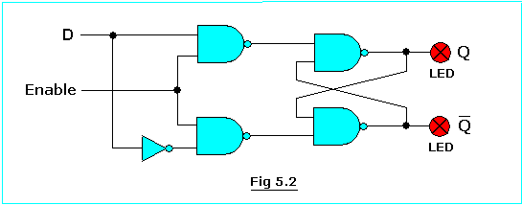

2. Construct the circuit which you have simulated on the logic trainer using the appropriate ICs. Connect the D and Enable inputs to the toggle switches on your trainer and the Q and Not Q outputs to LEDs. Hence verify that the results you obtained from circuit simulation by going through the sequence listed in truth table 5.2.

NB: If you have problems connecting your circuit, Login to blackboard on the Lab PC and go to the Lab Folder of the Course Documents Menu and Launch the Guide for Bistables Experiment. Guides for 5A and 5B are provided.

Enable | D | Q_{n+1} *
0 | 0
0 | 1
1 | 0
1 | 1
Table 5.2 D-type Bistable truth table

* Q_{n+1} refer to the new value of output Q after the application of the input control signals. Use the notation Q_{n} to denote the previous value of Q, i.e. the value of Q prior to the application of the new input states.

Is the D-type Bistable circuit in figure 5.2 level triggered or edge triggered?
Write in your own words the conclusions you can draw from this experiment.

Experiment C J-K Edge triggered flip-flop

Objective: | To understand the Synchronous operation of a J-K flip-flop using the 74LS112 IC.

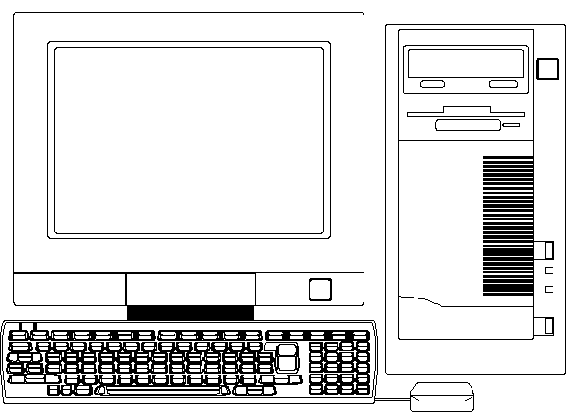 | Using your Notebook, activate NI Multisim and capture the circuit of 74LS112 JK flip-flop as shown in figure 5.3, the symbol of which can be found in either the TTL → 74LS library. In addition to the flip-flop, three SPDT switches, Vcc, DGnd and two probes will be required.

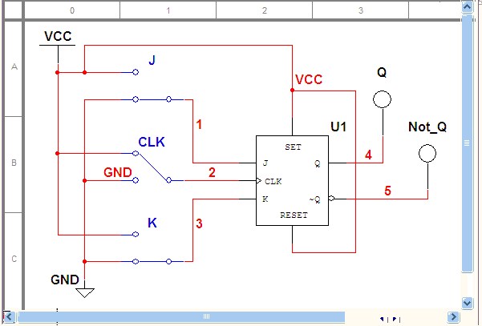
Fig. 5.3

Before simulation can start, the Preset (Set) and Clear (Reset) must be connected to logic 1. As you toggle the switches connected to the Clock and JK inputs, complete the truth table listed in Table 5.3.

J | K | Clock | Q | Not Q
0 | 0 | 0
0 | 0 | 1
0 | 0 | 0
0 | 1 | 1
0 | 1 | 0
1 | 0 | 1
1 | 0 | 0
1 | 1 | 1
1 | 1 | 0
Table 5.3 J-K type flip-flop truth table

- Optional: On the trainer, connect up the J-K flip-flop circuit using either half of the 74LS112 with the J and K inputs going to the toggle switches and the clock input connected to any of the two push-button switches, which are debounced. The Preset and Clear inputs need to be connected to logic 1 or to switches set to logic 1. Verify that the JK flip-flop has a truth table as summarized in Table 5.3.

Note: As you proceed down the truth table, set up the J K value first then change the clock logic level. Also bear in mind that with the push button switch, the 'resting' output logic state is either a 0 or a 1 depending on which output connector (A or Not A) is used. Refer to experiment 1 and the waveforms you've drawn to review on the operation of the push button switches if you are unsure.

3. Using the results from your previous experiments, complete the JK flip-flop truth table 5.3.2 for the 74LS112. Under the clock column either put a ↑ or ↓ to indicate the correct trigger (i.e. PGT or NGT) required for the clock signal.

J | K | Clock | Q | NOT Q | Remarks
0 | 0 | ↑ or ↓
0 | 1
1 | 0
1 | 1
Table 5.3.2 JK-type flip-flop truth table

Is the JK-type flip-flop level triggered or edge triggered?
Write in your own words the conclusions you can draw from this experiment.

